Robotic Arm Project

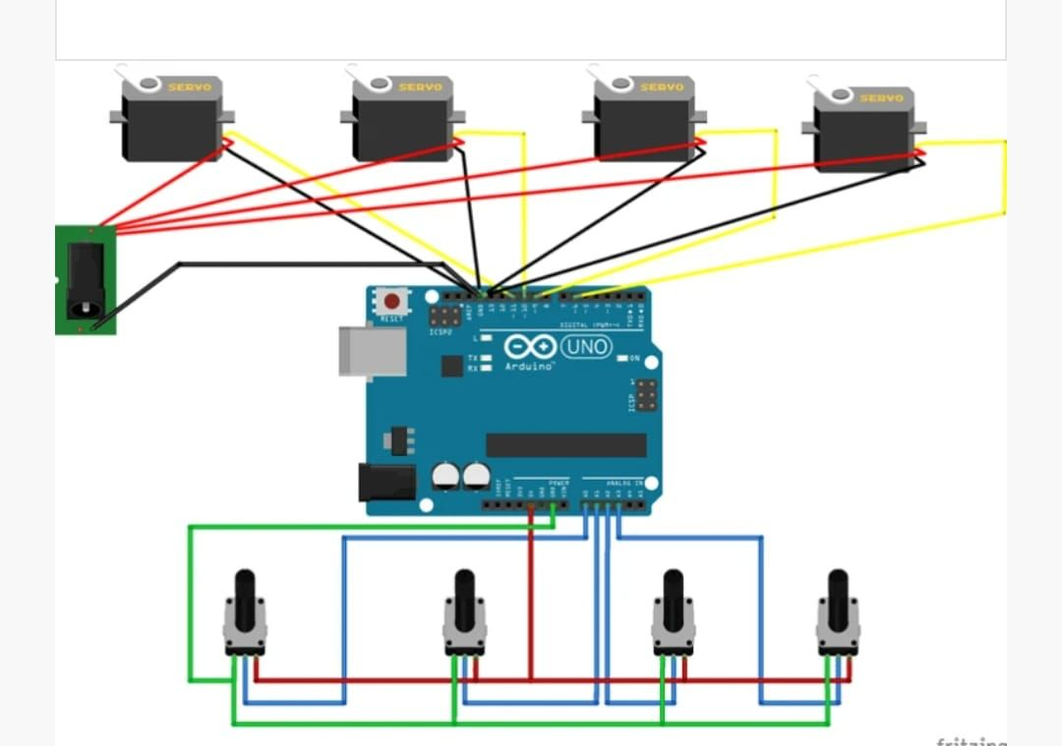

#include <Servo.h>

// --- Servo Motor Definitions ---
Servo baseServo;
Servo shoulderServo;
Servo elbowServo;

const int BASE_PIN = 9;
const int SHOULDER_PIN = 10;
const int ELBOW_PIN = 11;

// --- Input/Control Definitions ---
const int POT_BASE = A0;
const int POT_SHOULDER = A1;
const int POT_ELBOW = A2;

const int RECORD_BUTTON_PIN = 2;
const int PLAY_BUTTON_PIN = 3;

// --- Recording Array and Variables ---
#define MAX_POSITIONS 100 // Maximum number of positions to record

// Array to store the servo angles (3 columns for 3 servos)
int recordedPositions[MAX_POSITIONS][3];
int currentPositionIndex = 0;
bool isRecording = false;

// --- Timing ---
const int RECORD_INTERVAL_MS = 100; // Record a position every 100 milliseconds

unsigned long lastRecordTime = 0;

void setup() {
Serial.begin(9600);

// Attach servos to their pins
baseServo.attach(BASE_PIN);
shoulderServo.attach(SHOULDER_PIN);
elbowServo.attach(ELBOW_PIN);

// Initialize button pins
pinMode(RECORD_BUTTON_PIN, INPUT_PULLUP);
pinMode(PLAY_BUTTON_PIN, INPUT_PULLUP);

// Move all servos to a starting position (e.g., 90 degrees)
baseServo.write(90);
shoulderServo.write(90);
elbowServo.write(90);

Serial.println("Robotics Arm Ready. Press RECORD button to start.");
}

void loop() {
// Check for button presses and handle debouncing (simplified)
handleButtonPresses();

if (isRecording) {
recordPositions();
} else {
// When not recording, the potentiometers control the arm manually
manualControl();
}
}

/**
* @brief Handles the logic for the Record and Play buttons.
*/
void handleButtonPresses() {
// --- RECORD BUTTON Logic ---
if (digitalRead(RECORD_BUTTON_PIN) == LOW) {
// Debounce delay
delay(200);

if (!isRecording) {
// Start Recording
currentPositionIndex = 0; // Reset index for a new recording
isRecording = true;
Serial.println("--- RECORDING STARTED ---");
} else {
// Stop Recording
isRecording = false;
Serial.print("--- RECORDING STOPPED. Total Frames: ");
Serial.print(currentPositionIndex);
Serial.println(" ---");
}
// Wait for button release
while(digitalRead(RECORD_BUTTON_PIN) == LOW);
}

// --- PLAY BUTTON Logic ---
if (digitalRead(PLAY_BUTTON_PIN) == LOW) {
// Debounce delay
delay(200);

// Only play if not currently recording and we have recorded frames
if (!isRecording && currentPositionIndex > 0) {
Serial.println("--- PLAYBACK STARTED ---");
playbackPositions();
Serial.println("--- PLAYBACK FINISHED ---");
}
// Wait for button release
while(digitalRead(PLAY_BUTTON_PIN) == LOW);
}
}

/**
* @brief Reads potentiometers and moves the servos manually.
*/
void manualControl() {
int baseAngle = map(analogRead(POT_BASE), 0, 1023, 0, 180);
int shoulderAngle = map(analogRead(POT_SHOULDER), 0, 1023, 0, 180);
int elbowAngle = map(analogRead(POT_ELBOW), 0, 1023, 0, 180);

baseServo.write(baseAngle);
shoulderServo.write(shoulderAngle);
elbowServo.write(elbowAngle);
}

/**
* @brief Saves the current servo positions into the array at a set interval.
*/
void recordPositions() {
if (currentPositionIndex < MAX_POSITIONS) {
if (millis() - lastRecordTime >= RECORD_INTERVAL_MS) {
// Read current angles (which are being set by manualControl)
int baseAngle = map(analogRead(POT_BASE), 0, 1023, 0, 180);
int shoulderAngle = map(analogRead(POT_SHOULDER), 0, 1023, 0, 180);
int elbowAngle = map(analogRead(POT_ELBOW), 0, 1023, 0, 180);

// Store the angles
recordedPositions[currentPositionIndex][0] = baseAngle;
recordedPositions[currentPositionIndex][1] = shoulderAngle;
recordedPositions[currentPositionIndex][2] = elbowAngle;

currentPositionIndex++;
lastRecordTime = millis();
}
} else {
// Stop recording if the array is full
isRecording = false;
Serial.println("!!! Array Full! Recording Stopped Automatically !!!");
}
}

/**
* @brief Replays the saved servo positions sequentially.
*/
void playbackPositions() {
for (int i = 0; i < currentPositionIndex; i++) {
int baseAngle = recordedPositions[i][0];
int shoulderAngle = recordedPositions[i][1];
int elbowAngle = recordedPositions[i][2];

baseServo.write(baseAngle);
shoulderServo.write(shoulderAngle);
elbowServo.write(elbowAngle);

// Wait for the same interval used during recording for smooth playback
delay(RECORD_INTERVAL_MS);
}
}

